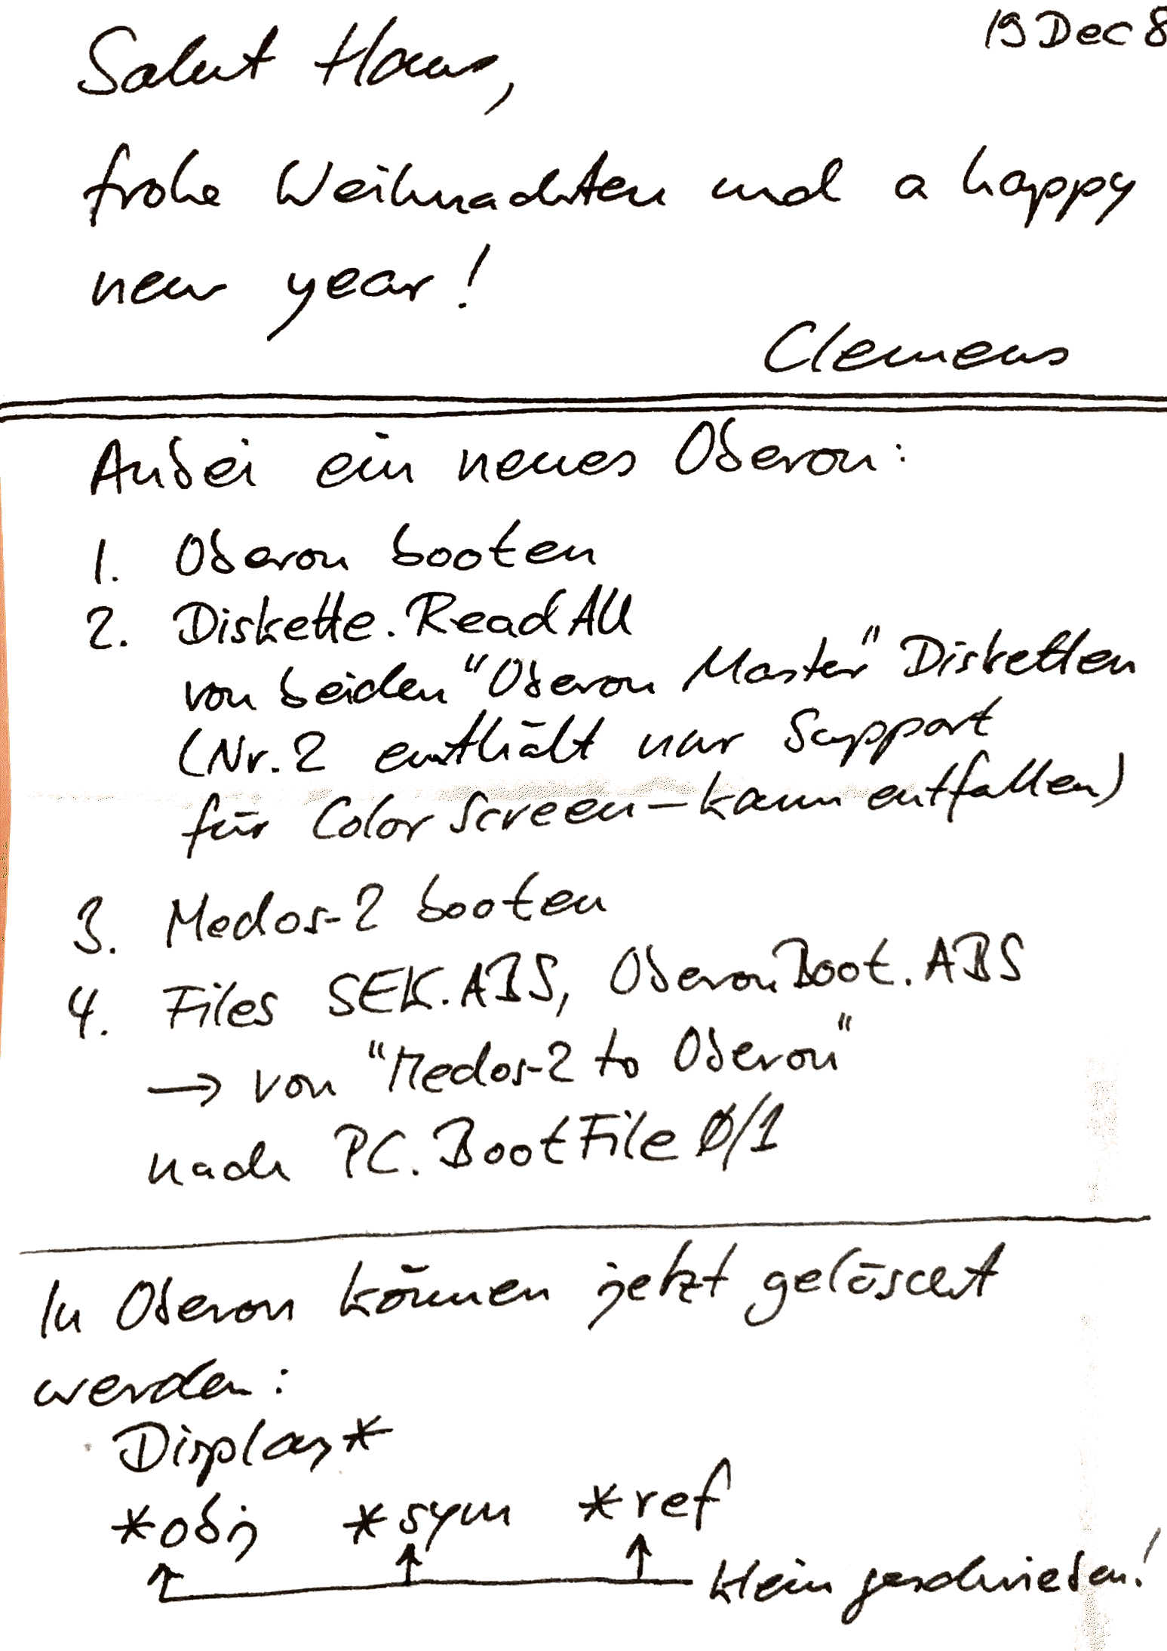

Installation Notes from Clemens Szyperski

1.Boot Oberon
2. Diskette.ReadAll
on both “Oberon Master” floppy disks
(Nr. 2 only contains support
for the Color Screen – can be omitted)
3. Boot Medos-2
4. Files SEK.ABS, OberonBoot.ABS
-> copy from “Medos-2 to Oberon”
to PC.BootFile0/1
In Oberon, now delete:
Display*
*obj *sym *ref
^ ^ ^ all lower-case letters

